Praktikum 11
Android MySQL Create dan Multi Read

1. Sebelum memulai dengan proyek Android, nyalakan XAMPP yang terpasang di komputer masing-masing. Lalu cek apakah localhost bisa diakses atau tidak.
2. Jika berhasil mengakses, gunakan PHPMyAdmin untuk membuat database “android” dan tabel “databarang” baru.
3. Kolom-kolom di tabel “users”:
+------------+--------------+------+-----+---------+----------------+
| Field | Type | Null | Key | Default | Extra |
+------------+--------------+------+-----+---------+----------------+
| id | int(11) | NO | PRI | NULL | auto_increment |
| kodebarang | varchar(100) | NO | UNI | NULL | |
| namabarang | varchar(100) | NO | | NULL | |
| kuantitas | int(11) | NO | | NULL | |
+------------+--------------+------+-----+---------+----------------+

4. Hasil dari Database dan Tabel:
DB android
+--------------------+
| Database |
+--------------------+
| android |
| information_schema |
| mysql |
| performance_schema |
+--------------------+
Tabel databarang
+-------------------+
| Tables_in_android |
+-------------------+
| databarang |
+-------------------+

5. Isilah dengan data Dummy untuk menguji Aplikasi Android nanti, contoh:
+----+-------------------+------------+-----------+
| id | kodebarang | namabarang | kuantitas |
+----+-------------------+------------+-----------+
| 1 | INV-5DD9FC0BEAE04 | meja | 10 |
| 2 | INV-5DD9FC9E0D43A | kursi | 10 |
| 3 | INV-5DD9FCBCDAAFE | lampu | 10 |
+----+-------------------+------------+-----------+

6. Berikutnya adalah membuat file PHP di htdocs (Pastikan file bisa diakses nanti!)
connect.php
<?php
$HOST = 'localhost';
$USER = 'admin';
$PASS = 'password';
$DB = 'android';
$CON = mysqli_connect($HOST,$USER,$PASS,$DB) or die(mysqli_error($CON));
?>
create.php
<?php
require_once('connect.php');
// Generator Kode Unik
$kodebarang = strtoupper(uniqid("INV-", FALSE));
// Ambil Data dengan GET
$namabarang = $_GET['nama'];
$kuantitas = $_GET['jumlah'];

// Query Data
if(!$namabarang || !$kuantitas){
echo json_encode(array('message'=>'Field Kosong!'));
}else{
$query = mysqli_query($CON, "INSERT INTO databarang (kodebarang,namabarang,kuantitas) VALUES ('$kodebarang','$namabarang','$kuantitas')");
if($query)
{
echo json_encode(array('message'=>'Data Sukses Dimasukkan!'));
}
else
{
echo json_encode(array('message'=>'Data Gagal Dimasukkan!'));
}
}
?>
read.php
<?php
require_once('connect.php');
$result = array();
$query = mysqli_query($CON,"SELECT * FROM databarang ORDER BY id ASC");
while($row = mysqli_fetch_assoc($query)){
$result[] = $row;
}
echo json_encode(array('result'=>$result));
?>

7. Tes koneksi ke PHP dengan menggunakan Web Browser, gunakan http://localhost/android/read.php (tergantung dari letak file!!!). Jika benar akan muncul gambar berikut:
{"result":[{"id":"1","kodebarang":"INV-5DD9FC0BEAE04","namabarang":"meja","kuantitas":"10"},{"id":"2","kodebarang":"INV-5DD9FC9E0D43A","namabarang":"kursi","kuantitas":"10"},{"id":"3","kodebarang":"INV-5DD9FCBCDAAFE","namabarang":"lampu","kuantitas":"10"},{"id":"4","kodebarang":"INV-5DDA4C519A0B4"}]}

8. Lalu buatlah proyek baru dengan Android Studio
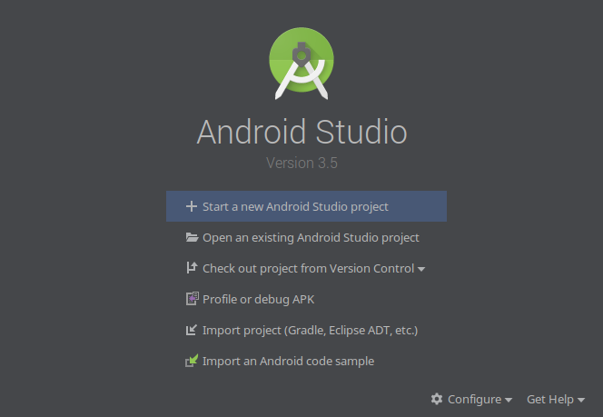

9. Pilih Empty Activity untuk memulai aplikasi baru
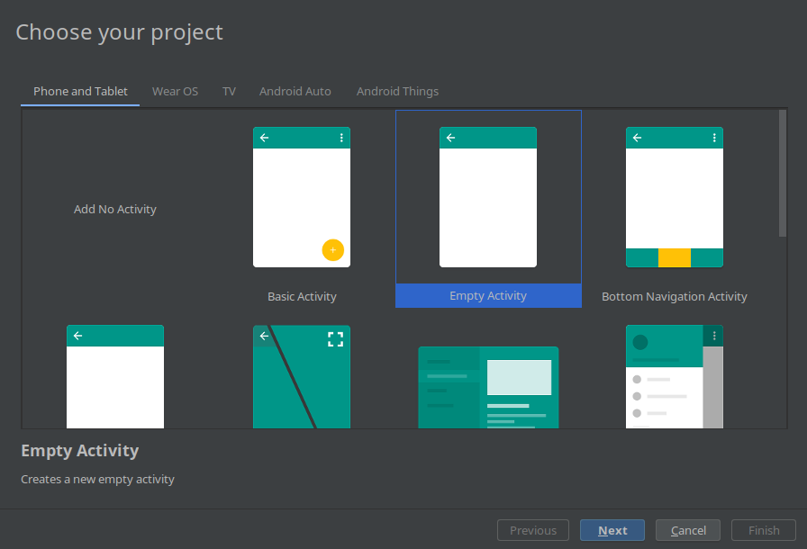

10. Bukalah file build.gradle (Module: app) lalu tambahkan tulisan tebal putih berikut:
dependencies {
implementation fileTree(dir: 'libs', include: ['*.jar'])
implementation"org.jetbrains.kotlin:kotlin-stdlib-jdk7:$kotlin_version"
implementation 'androidx.appcompat:appcompat:1.0.2'
implementation 'androidx.core:core-ktx:1.0.2'
implementation 'androidx.constraintlayout:constraintlayout:1.1.3'
testImplementation 'junit:junit:4.12'
androidTestImplementation 'androidx.test:runner:1.1.1'
androidTestImplementation 'androidx.test.espresso:espresso-core:3.1.1'
implementation 'com.amitshekhar.android:jackson-android-networking:1.0.2'
}

11. Sync Project, lalu tambahkan kode berikut ke AndroidManifest.xml
<?xml version="1.0" encoding="utf-8"?>
<manifest xmlns:android="http://schemas.android.com/apk/res/android"
package="com.example.mysqlcr">
<uses-permission android:name="android.permission.INTERNET" />
<application
android:usesCleartextTraffic="true">
.......

12. Kemudian buatlah Layout Pertama sebagai berikut:
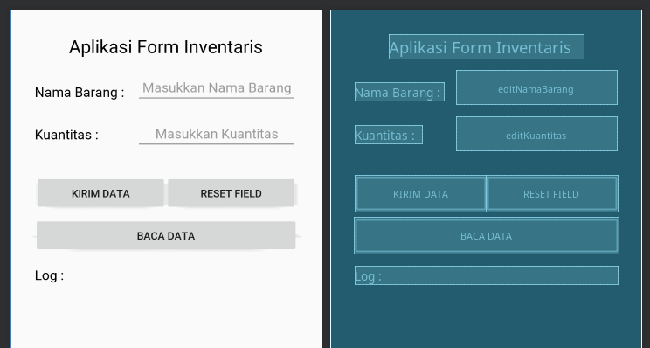
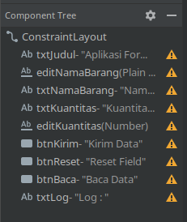

13. Kemudian edit MainActivity.kt
package com.example.mysqlcr
import android.content.Intent
import androidx.appcompat.app.AppCompatActivity
import android.os.Bundle
import android.util.Log
import android.widget.Button
import android.widget.EditText
import android.widget.TextView
import android.widget.Toast
import com.androidnetworking.AndroidNetworking
import com.androidnetworking.common.Priority
import com.androidnetworking.error.ANError
import com.androidnetworking.interfaces.JSONObjectRequestListener
import org.json.JSONObject
class MainActivity : AppCompatActivity() {
override fun onCreate(savedInstanceState: Bundle?) {
super.onCreate(savedInstanceState)
setContentView(R.layout.activity_main)
// Inisialisasi
var editNamaBarang = findViewById<EditText>(R.id.editNamaBarang)
var editKuantitas = findViewById<EditText>(R.id.editKuantitas)
var btnKirim = findViewById<Button>(R.id.btnKirim)
var btnReset = findViewById<Button>(R.id.btnReset)
var btnBaca = findViewById<Button>(R.id.btnBaca)
var txtLog = findViewById<TextView>(R.id.txtLog)
AndroidNetworking.initialize(applicationContext)
val SERVER = "http://192.168.100.2/android/"
// Aksi Button
btnKirim.setOnClickListener {
// Pengiriman dengan GET (Merujuk ke create.php)
val CREATE = SERVER+"create.php?nama=" + editNamaBarang.getText().toString() + "&jumlah=" + editKuantitas.getText().toString()
// Gunakan GET untuk Mengirim Data
AndroidNetworking.get(CREATE)
.setPriority(Priority.MEDIUM)
.build()
.getAsJSONObject(object : JSONObjectRequestListener {
// Jika Ada Respon Server
override fun onResponse(response: JSONObject?) {
// Tampilkan ke Log
txtLog.text = "Log : " + response?.getString("message")
// Jika Sukses pergi ke Aktivitas Daftar Barang
if(response?.getString("message")?.contains("Sukses")!!){
txtLog.text = "Log : " + response?.getString("message")
}
}
override fun onError(anError: ANError?) {
Log.d("ONERROR",anError?.errorDetail?.toString())
txtLog.text = "Log : Connection Failure"
}
})
}
btnReset.setOnClickListener {
// Reset Edit Text
editNamaBarang.setText("")
editKuantitas.setText("")
}
btnBaca.setOnClickListener {
val int : Intent = Intent(this,ReadActivity::class.java)
startActivity(int)
}
}
}

14. Kemudian buatlah Layout Kedua dengan ConstraintLayout seperti:
activity_read.xml
<?xml version="1.0" encoding="utf-8"?>
<androidx.constraintlayout.widget.ConstraintLayout xmlns:android="http://schemas.android.com/apk/res/android"
xmlns:app="http://schemas.android.com/apk/res-auto"
xmlns:tools="http://schemas.android.com/tools"
android:layout_width="match_parent"
android:layout_height="match_parent"
tools:context=".ReadActivity">
<ListView
android:id="@+id/list_databarang"
android:layout_width="0dp"
android:layout_height="350dp"
app:layout_constraintEnd_toEndOf="parent"
app:layout_constraintStart_toStartOf="parent"
app:layout_constraintTop_toTopOf="parent" />
<Button
android:id="@+id/btnKembali"
android:layout_width="0dp"
android:layout_height="wrap_content"
android:layout_marginTop="8dp"
android:text="Kembali"
app:layout_constraintEnd_toEndOf="parent"
app:layout_constraintStart_toStartOf="parent"
app:layout_constraintTop_toBottomOf="@+id/list_databarang" />
<TextView
android:id="@+id/txtLog"
android:layout_width="0dp"
android:layout_height="wrap_content"
android:layout_marginStart="32dp"
android:layout_marginTop="24dp"
android:layout_marginEnd="32dp"
android:text="Log : "
android:textAlignment="textStart"
android:textColor="#000"
app:layout_constraintEnd_toEndOf="parent"
app:layout_constraintStart_toStartOf="parent"
app:layout_constraintTop_toBottomOf="@+id/btnKembali" />
</androidx.constraintlayout.widget.ConstraintLayout>

15. Lalu buatlah ReadActivity.kt dengan isi sebagai berikut:
ReadActivity.kt
package com.example.mysqlcr
import android.content.Intent
import androidx.appcompat.app.AppCompatActivity
import android.os.Bundle
import android.util.Log
import android.widget.*
import com.androidnetworking.AndroidNetworking
import com.androidnetworking.common.Priority
import com.androidnetworking.common.Priority.*
import com.androidnetworking.error.ANError
import com.androidnetworking.interfaces.JSONObjectRequestListener
import org.json.JSONObject
class ReadActivity : AppCompatActivity() {
override fun onCreate(savedInstanceState: Bundle?) {
super.onCreate(savedInstanceState)
setContentView(R.layout.activity_read)
// Inisialisasi ListView dan Server
var list_databarang = findViewById<ListView>(R.id.list_databarang)
val btnKembali = findViewById<Button>(R.id.btnKembali)
var txtLog = findViewById<TextView>(R.id.txtLog)
AndroidNetworking.initialize(applicationContext)
val READ = "http://192.168.100.2/android/read.php"
// Ambil Data ke Server
AndroidNetworking.get(READ)
.setPriority(MEDIUM)
.build()
.getAsJSONObject(object : JSONObjectRequestListener {
// Jika Ada Respon dari Server
override fun onResponse(response: JSONObject?) {
txtLog.text = "Log : Loading Data"
// Ambil Data dengan nama result (Cek read.php)
val jsonArray = response?.optJSONArray("result")
// Jika Kosong
if(jsonArray?.length() == 0){
Toast.makeText(applicationContext,"Data Barang Kosong",Toast.LENGTH_SHORT).show()
txtLog.text = "Log : Data Kosong"
}
// Buat Array untuk Data
val listBarang = arrayOfNulls<String>(jsonArray?.length()!!)
// Jika Ada Data
for(i in 0 until jsonArray?.length()!!){
// Ambil Data Satu per Satu (Iteratif)
val jsonObject = jsonArray?.optJSONObject(i)
// Susun Data menjadi Data Array
listBarang[i] = jsonObject.getString("id") + " - " + jsonObject.getString("kodebarang") + "\n" + jsonObject.getString("namabarang") + " : " + jsonObject.getString("kuantitas")
// Lempar Data ke ListView Adapter
if(jsonArray?.length() - 1 == i){
val adapter = ArrayAdapter(this@ReadActivity,android.R.layout.simple_list_item_1,listBarang)
adapter.notifyDataSetChanged()
list_databarang.adapter = adapter
txtLog.text = "Log : Data Loaded"
}
}
}
override fun onError(anError: ANError?) {
Log.d("ONERROR",anError?.errorDetail?.toString())
Toast.makeText(applicationContext,"Connection Failure",Toast.LENGTH_SHORT).show()
txtLog.text = "Log : ERROR"
}
})
btnKembali.setOnClickListener {
val int2 : Intent = Intent(this,MainActivity::class.java)
startActivity(int2)
}
}
}

16. Kompile Kode dan Jalankan

